Project Description  
  
Shoppinghut

The project shoppinghut consists of 3 pages components.  
Each of which is described below:

1. Home Page
2. The detail page for each item.
3. The cart Page.

* The Home Page  
    
  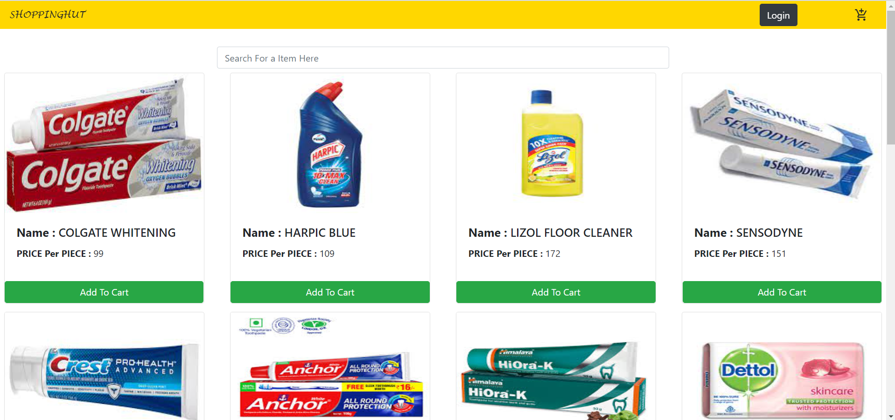

This is how the home page looks.  
It displays all the items that are on the portal .

* On clicking the cart icon on the top right of the navbar the user is redirected to the cart page.  
  If there is no item in the user’s cart then a message is displayed stating the there is no item in the cart and the user is redirected to the home page again.  
  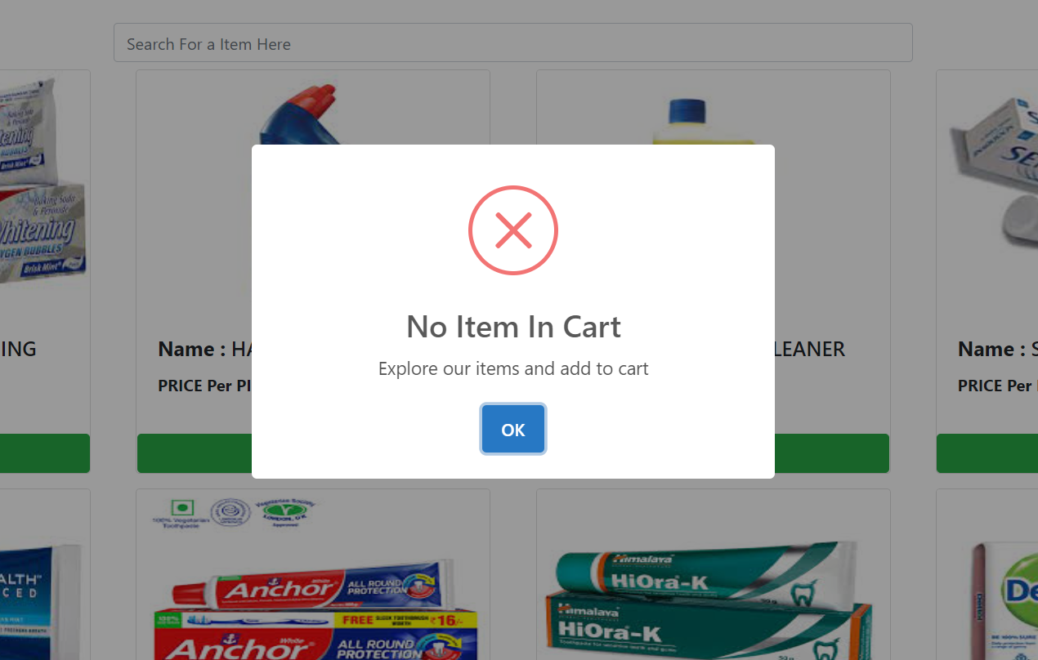

1. On clicking the login button on top right , the user will be able to login into the portal and see the cart items saved earlier.  
   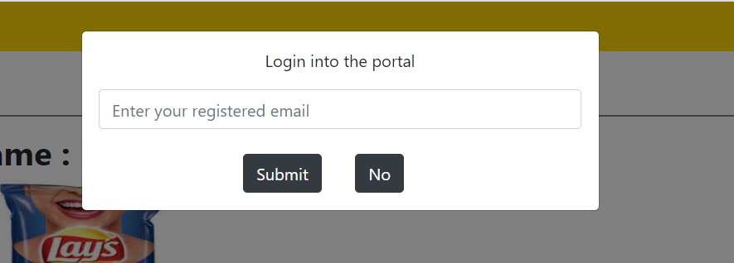

* If the user enters a mail address that is not registered in the portal then the user will get an error message.  
  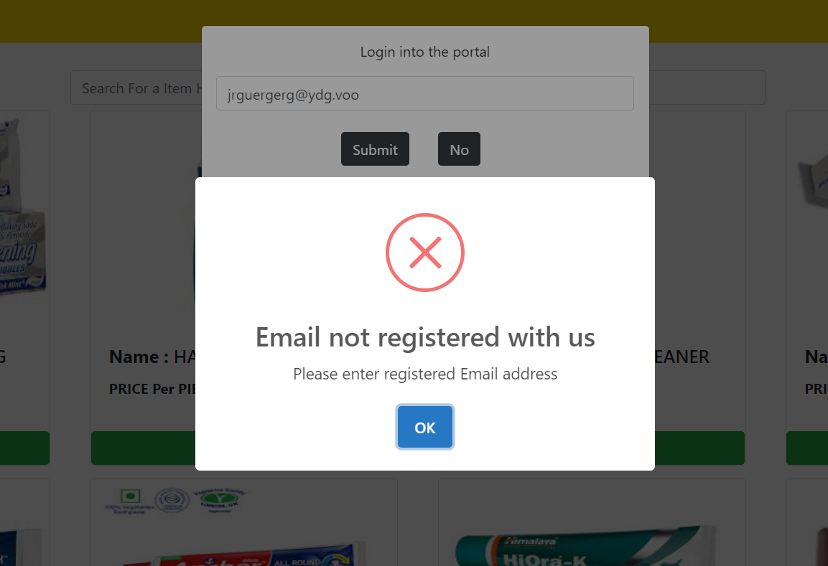
* If the user enters a correct mail address then the user is logged in successfully and the cart items are updated accordingly.  
  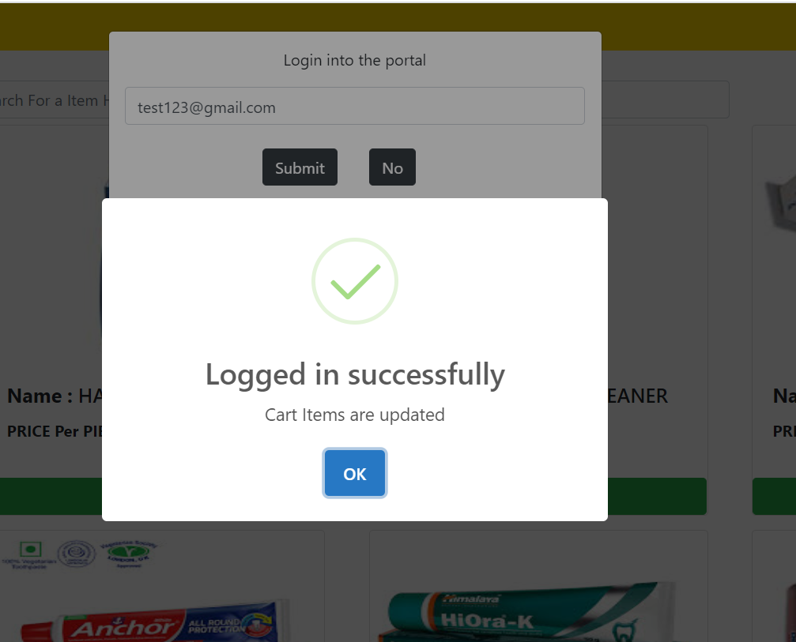
* There is a search bar in the page .  
  as soon as user starts entering data into the search bar, the product displayed gets filtered as per the search string.  
  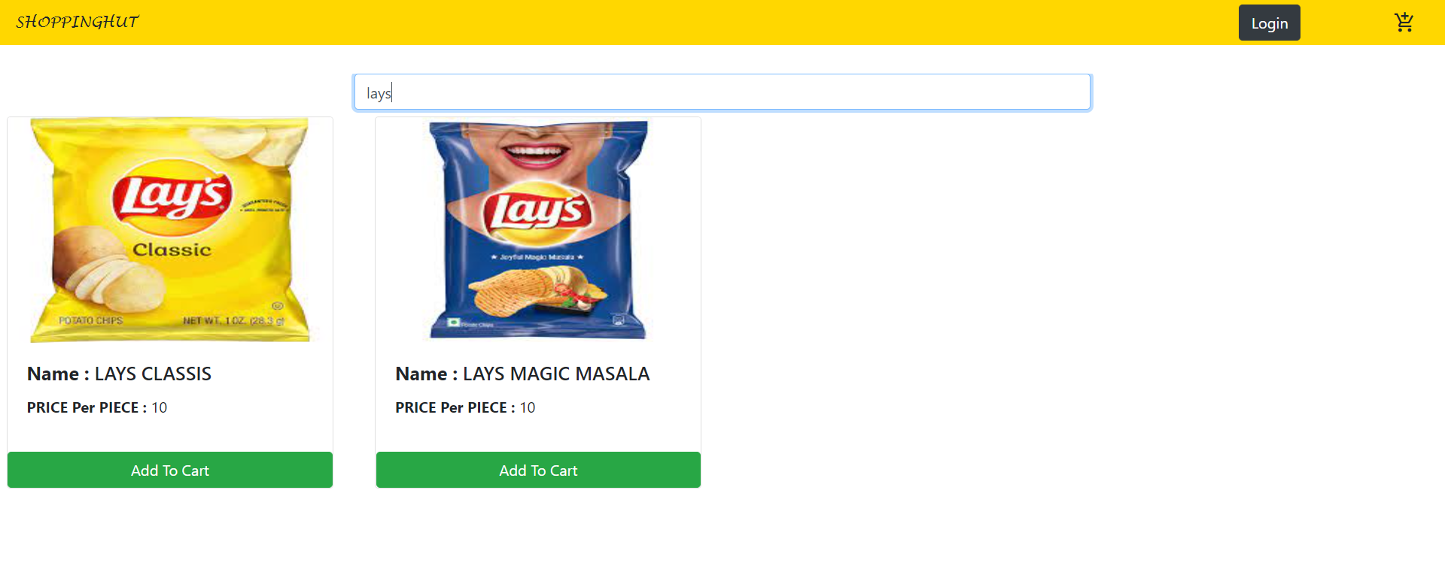
* The Detail Page

The detail page shows the detailed view of the product upon clicking the product on the home page.  
  
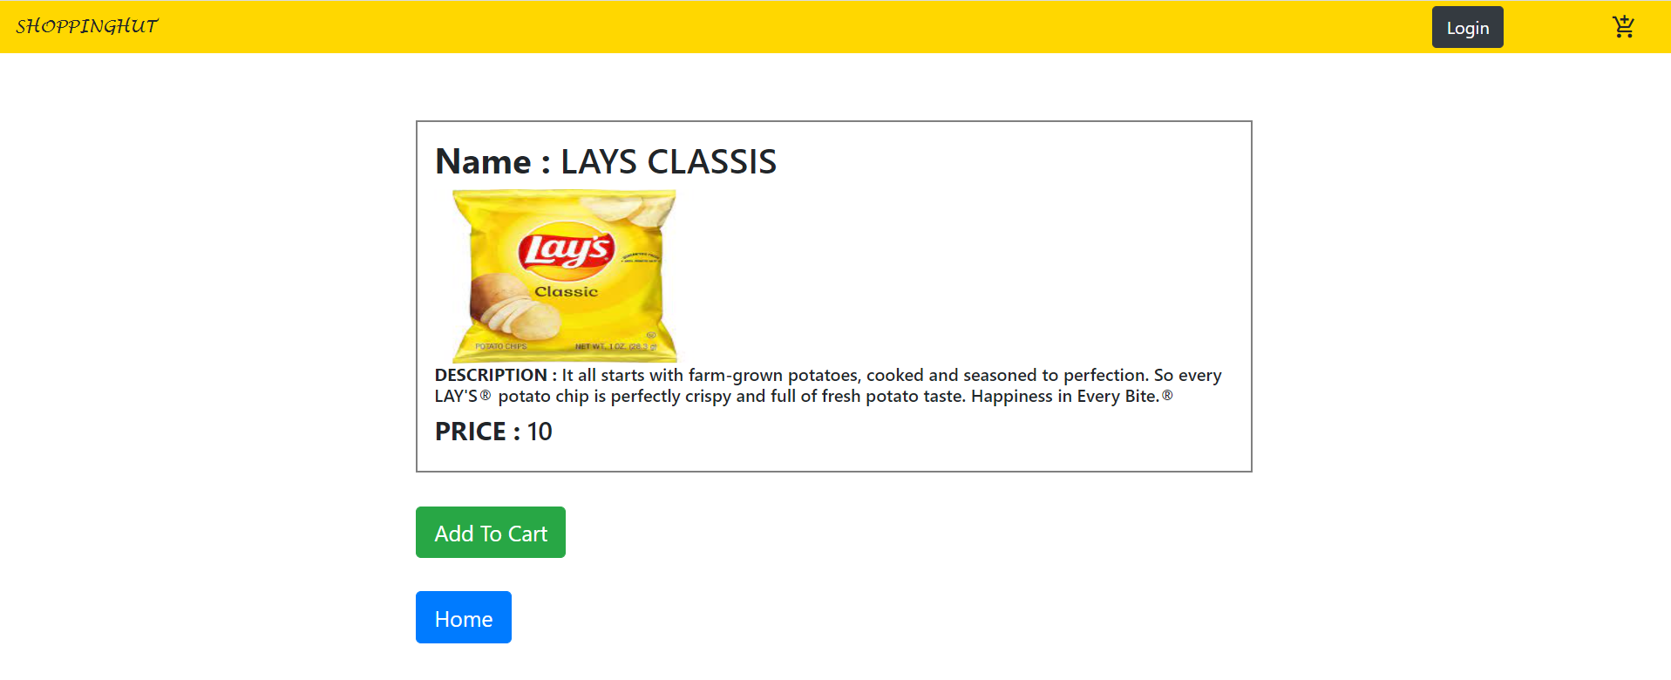

There are two buttons in the detail page one to add the item to the cart and the other one to go back to home page.

* The Cart Page

The cart page shows the items that are added to the cart by the user .  
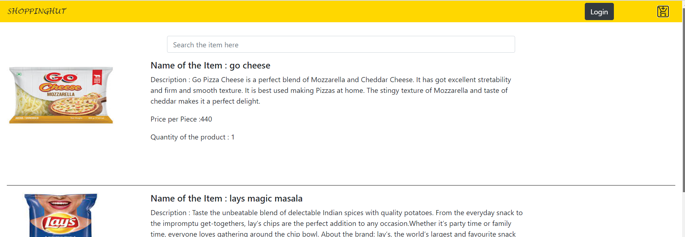

It displays the product and the quantity of each product added to the cart.  
  
It also displays the total amount for the products in the cart at the end of the page.  
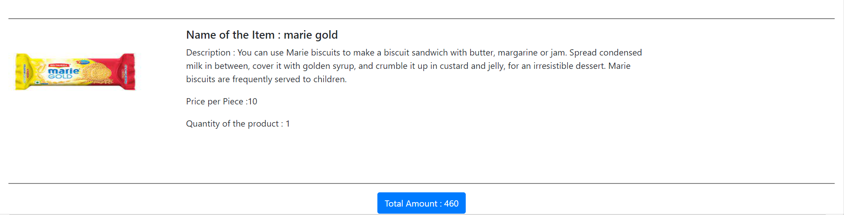

Whenever a user adds an item to the cart he will get the success message notifying that the item is added to the cart successfully.  
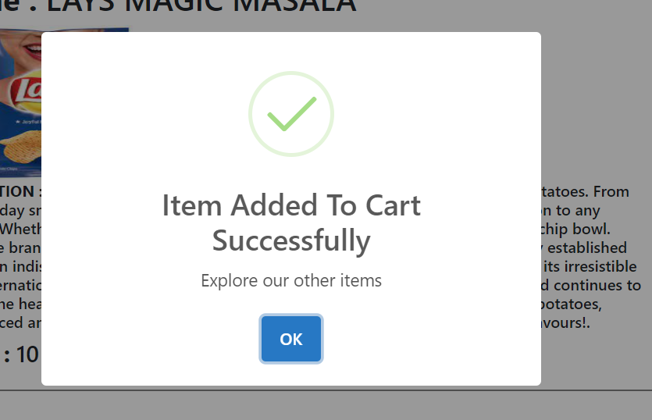

The Portal is fully responsive at all screen sizes.  
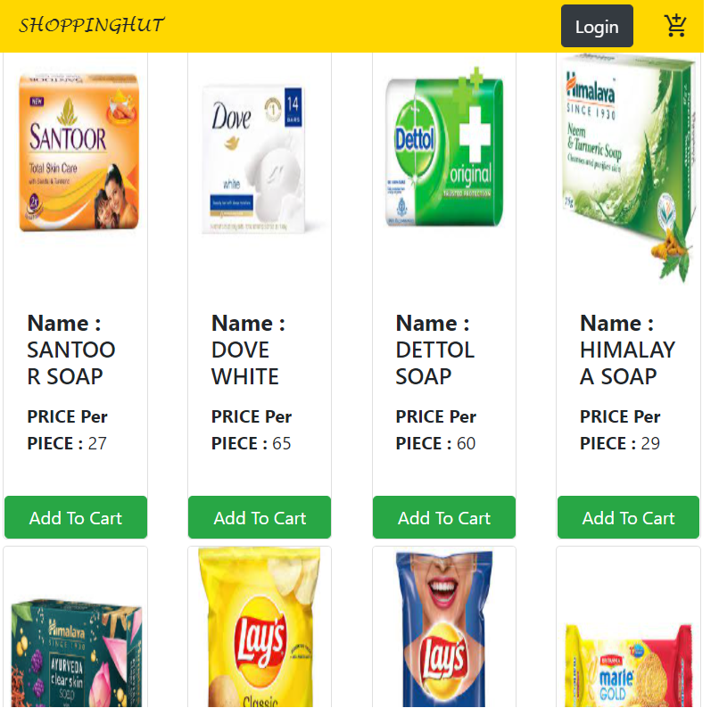 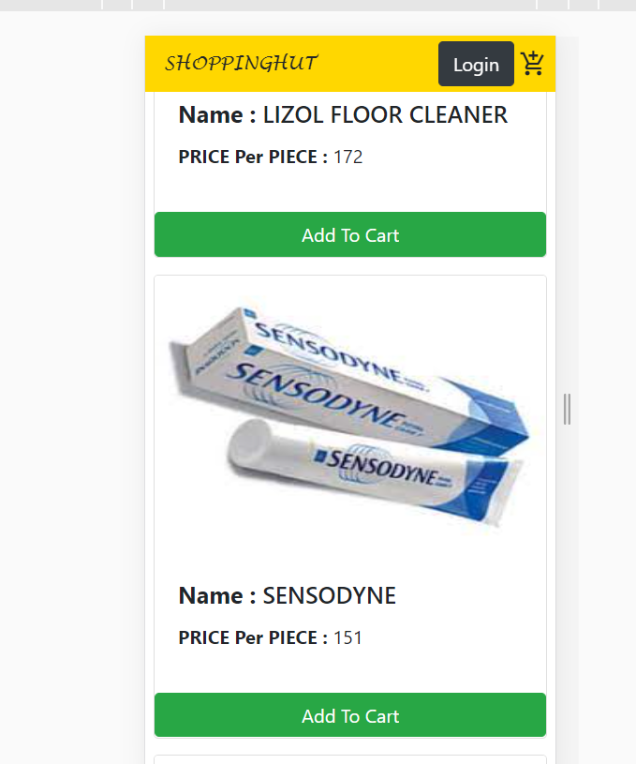



IMP:   
  
For adding the Item from postman

User can use the URL: <http://localhost:3000/v1/addItem>  
In the Body the user has to pass parameters as   
1. name

2. description

3. price

4. image- (to be uploaded from local disk)  
  
The name of the parameters should be as specified above.